Case on Banking Loan Risk (Dashboard)

I’ll keep simple English, clear structure, and business storytelling

Project :- Loan Risk & Churn Analysis
Achieved
“Built an end-to-end loan risk and churn analytics solution using Python, MySQL, and Power BI, identifying 13% high-risk customers and delivering actionable insights through a 6-page executive dashboard.”
End-to-End Data Analytics Project (Jupyter Notebook→ MySQL → Power BI)
1. Problem Statement
Banks face significant financial losses due to loan defaults and customer churn.
While most customers repay loans responsibly, a small group of high-risk customers can create disproportionate risk for the organization.
The key challenges addressed in this project are:
- Identifying high-risk loan customers
- Understanding why customers churn or default
- Segmenting customers into Low, Medium, and High Risk
- Presenting insights clearly to non-technical stakeholders
- Supporting data-driven decision making using dashboards
This project aims to build a data-driven loan risk and churn monitoring system using Python, SQL, and Power BI.

2. Objective (WHAT you want to achieve)
To analyze customer financial behavior, build a loan risk model, and identify high-risk churn customers using data analytics and Power BI.

Thought Process and Approach :-
- First of all , after get to know the issue/problem then starts to find the solution/goal.
set the goals (what to achieve ?).
- Find /gather or collecting the data from different sources.
- Once , collected the data then create a new relational database in MySQL ,
- By using connector and SQL alchemy ,import engine to extract the Raw data (tables) from MySQL to Jupyter Notebook.
- Then start normalize the raw data (after data cleaning),
- Next, do all EDA(Exploratory data analysis) like perform all necessary step which is required for this project like creating or adding new columns , feature engineering etc.
- After this all extract the new and cleaned table into the MySQL database for dashboard creation in Power BI.

I’ll describe in brief , and step by step

- About Dataset (Dataset Overview) –

This dataset basically contains information about bank details ,various client details which consists of multiple tables which are interlinked with each other through keys like primary key and foreign key.
The various tables are Banking Relationship, Client-Banking, Gender, Investment Advisor and Period.

The dataset contains 3,000 banking customers with financial and behavioral attributes.
The data represents a typical retail banking portfolio.
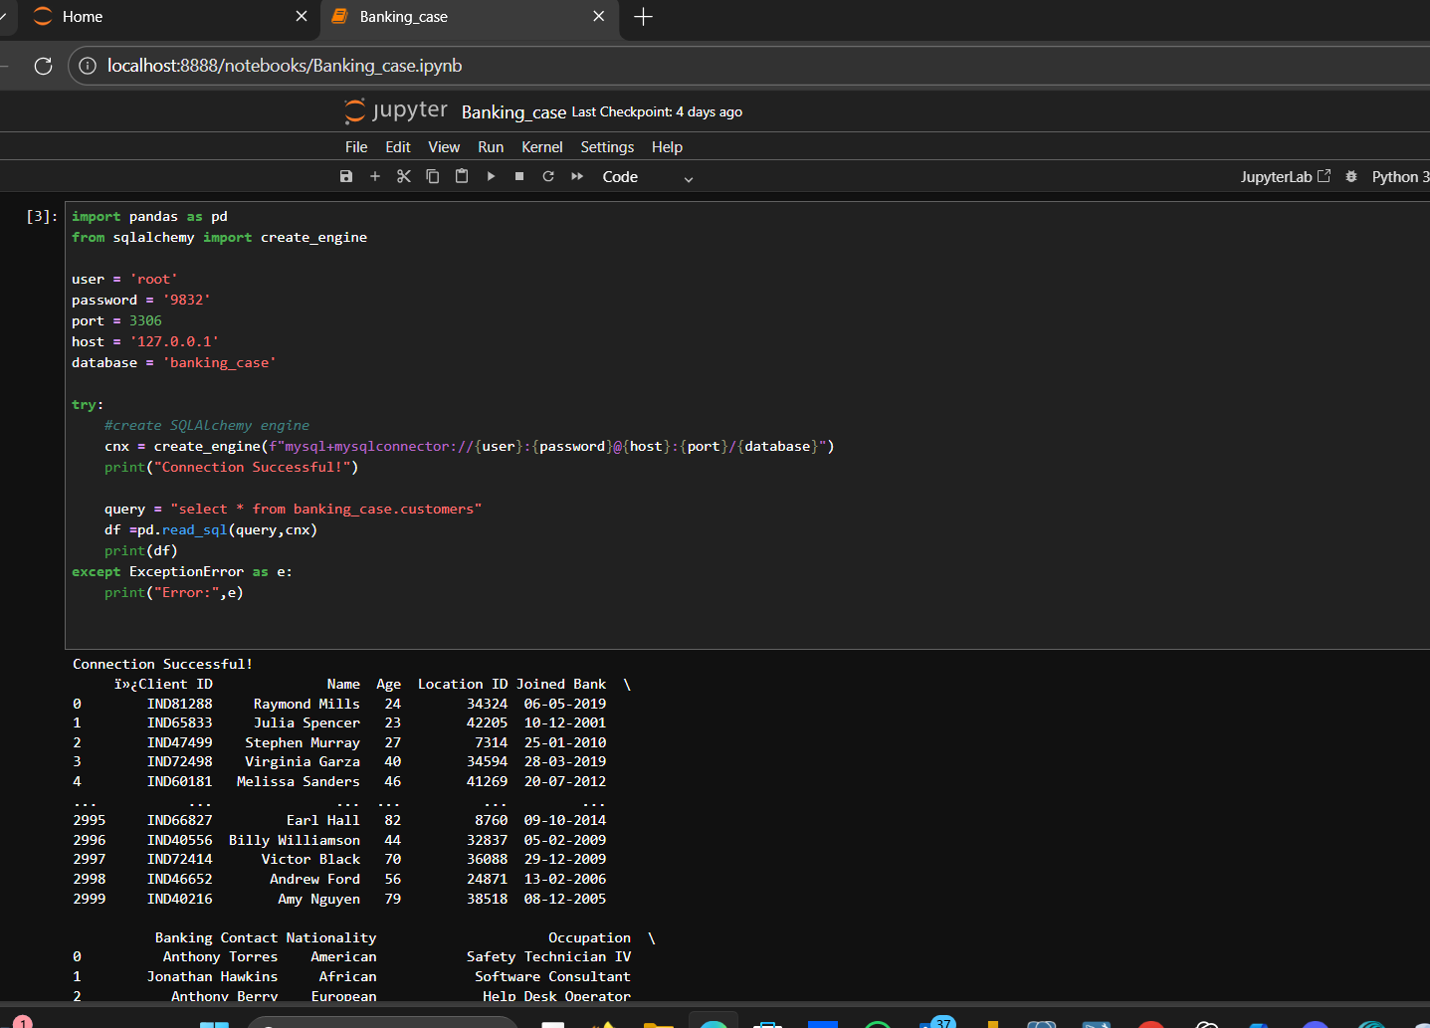
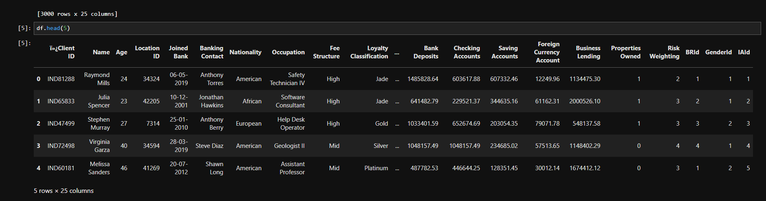
- Project Architecture (End-to-End Flow)
This project follows a real-world analytics workflow:
- Data Processing & Feature Engineering
→ Jupyter Notebook (Python)
- Data Storage & Aggregation
→ MySQL Database
- Business Intelligence & Visualization
→ Power BI Dashboard (6 Pages)
This architecture reflects how analytics projects are executed in actual banking and financial organizations.

- Data Preparation & Feature Engineering (Jupyter Notebook)

4.1 Data Cleaning
- Checked for missing values
- Verified numeric scales
- Normalized ratios (e.g., debt-to-income)
- Ensured consistency across financial variable
- Eleminate outliers
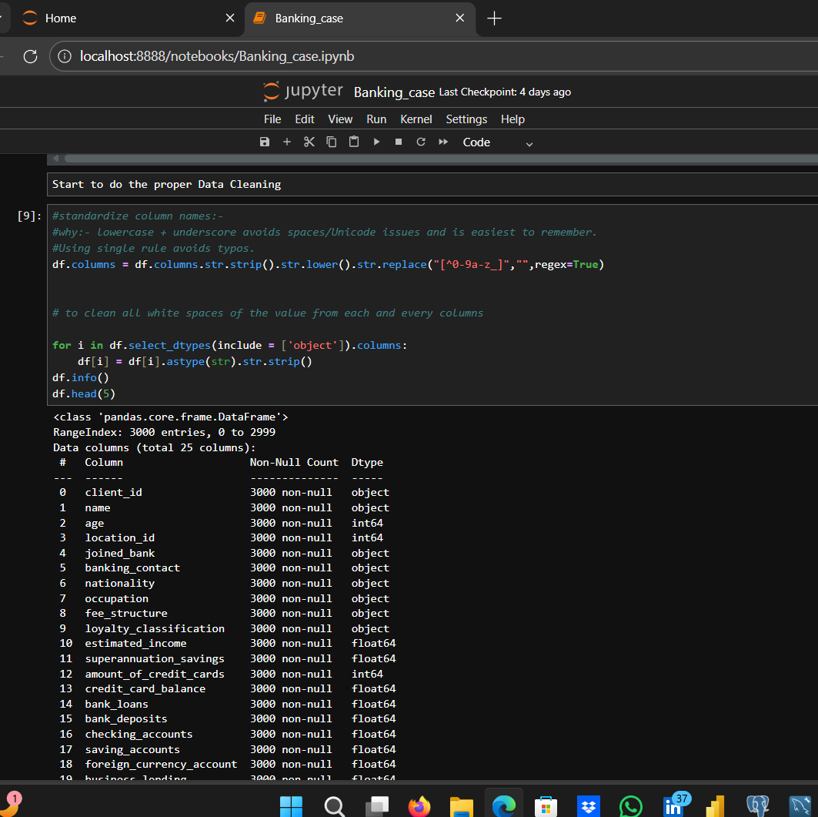
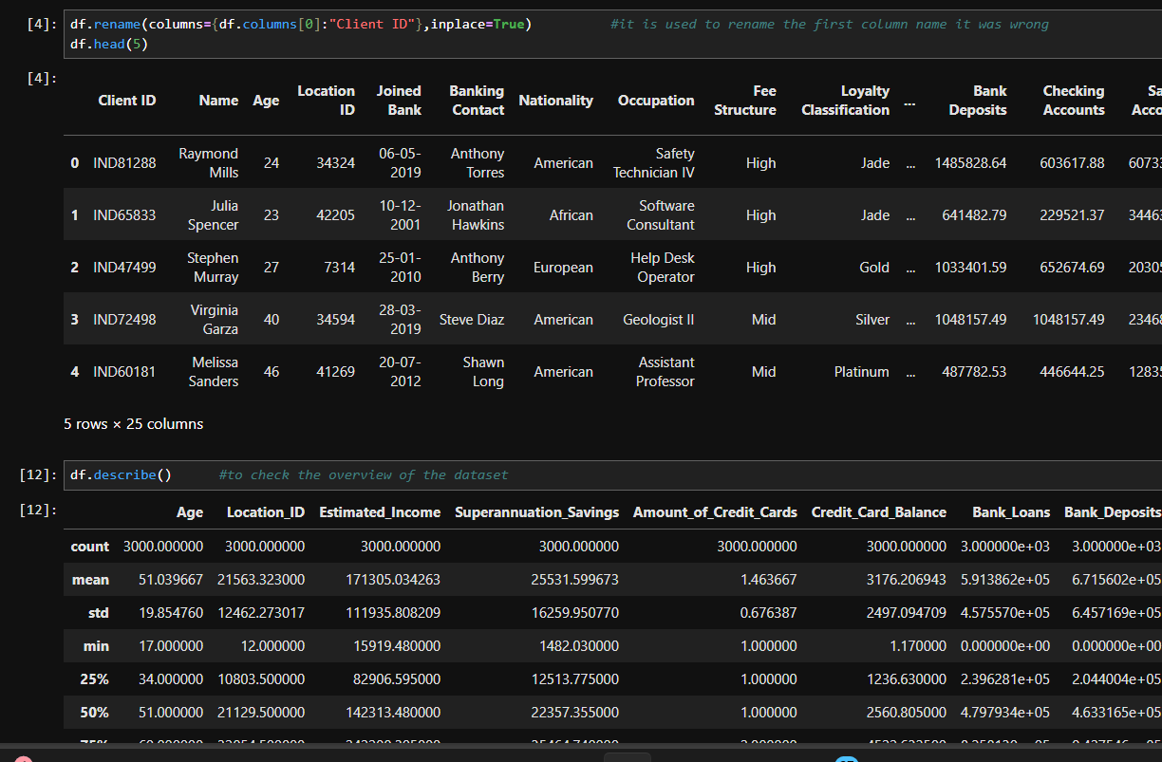
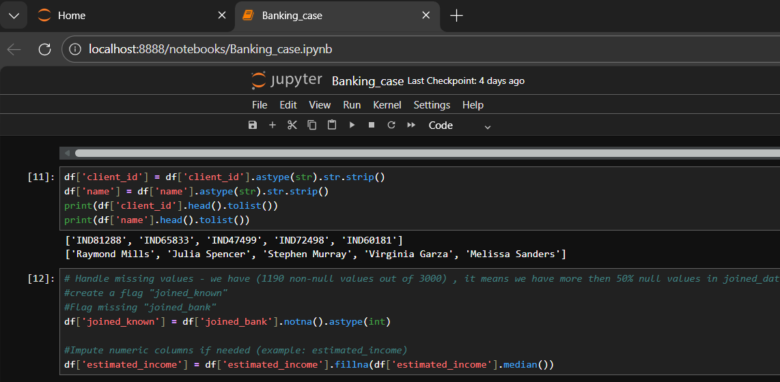
Deal or remove outliers
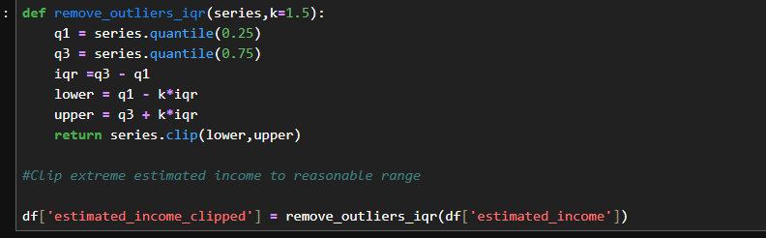

4.2 Loan Risk Churn Definition
Two churn modeling approaches were tested:
Method 1: Rule-Based Risk Paths (Final Choice)
Customers are flagged as high-risk churn if they meet any of the following:
- High debt-to-income + high risk score
- Low deposits + high total debt + low income
- New customer with high risk score
This method produced a realistic churn rate (~13%), which aligns with real banking scenarios.
Chosen because it is interpretable, business-friendly.
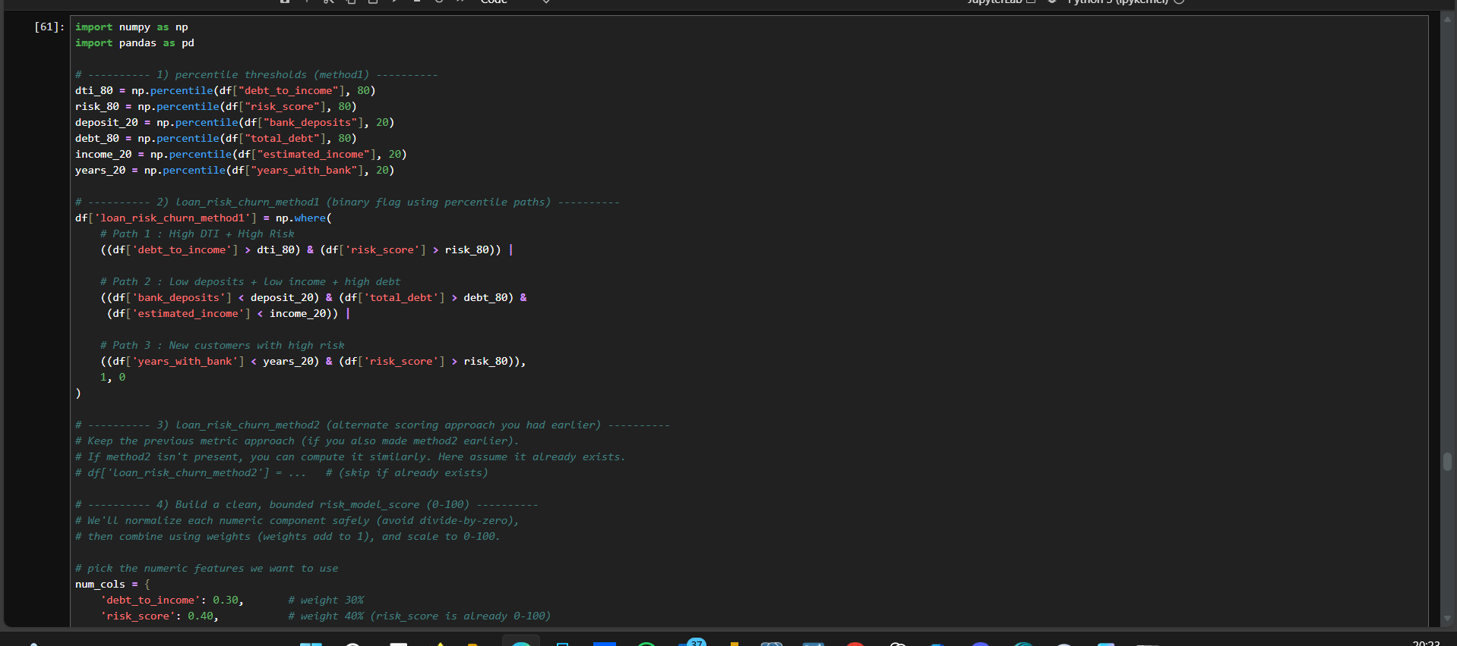
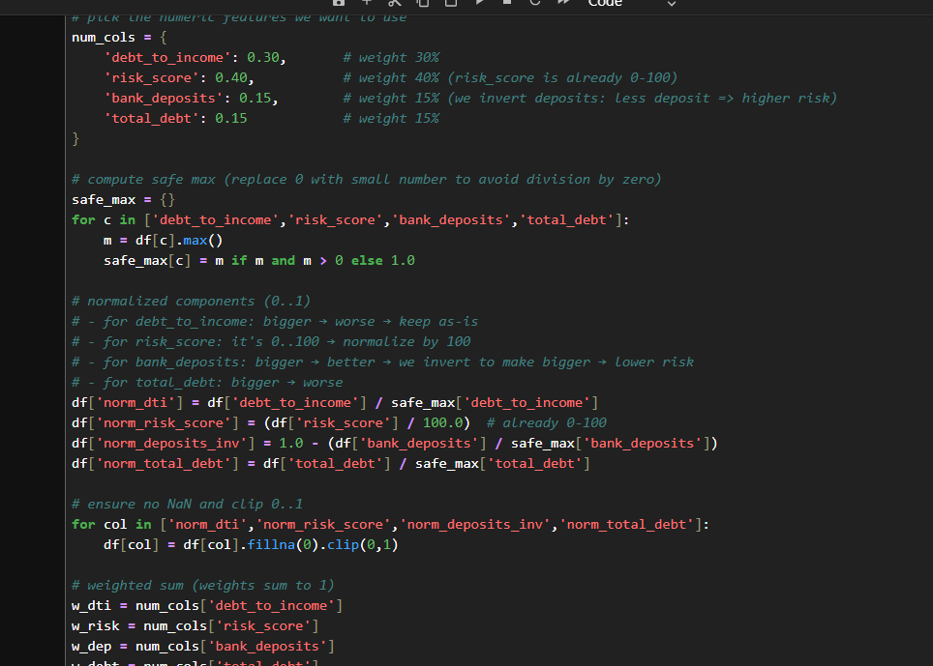
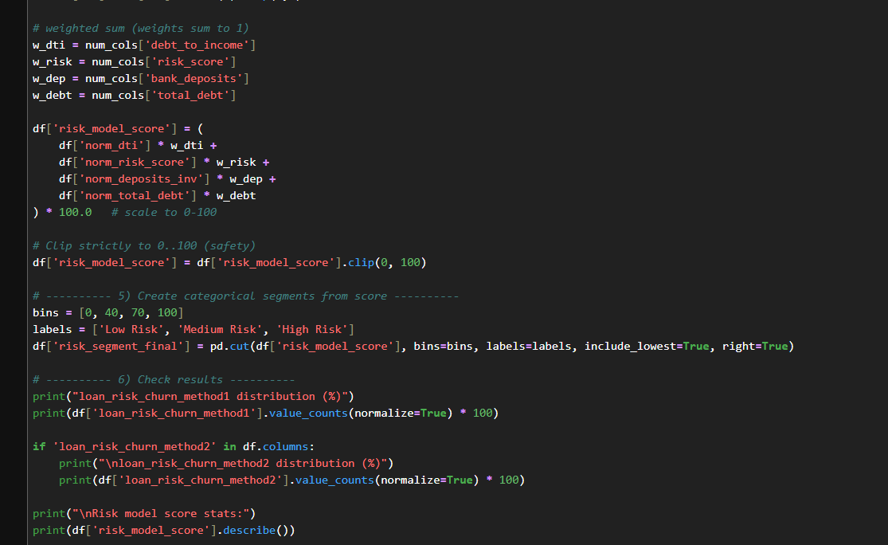
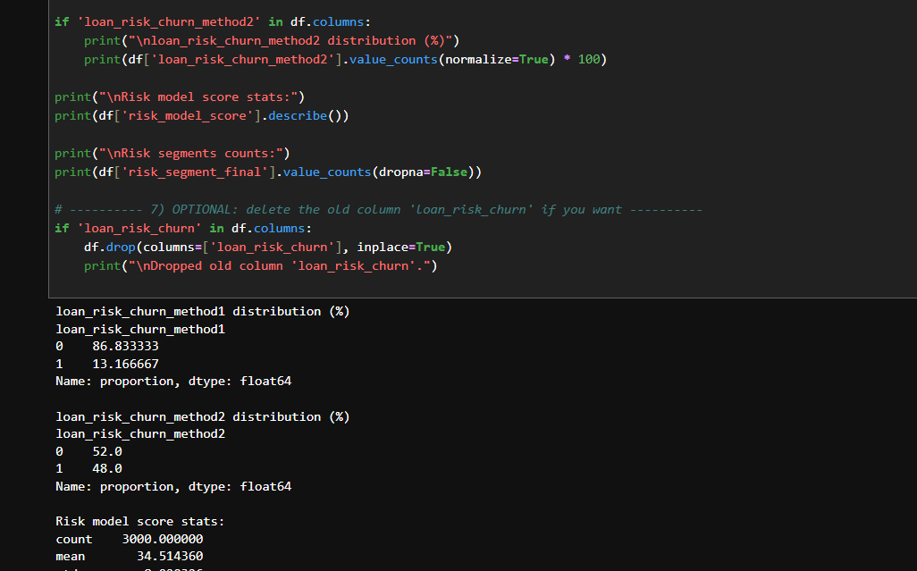
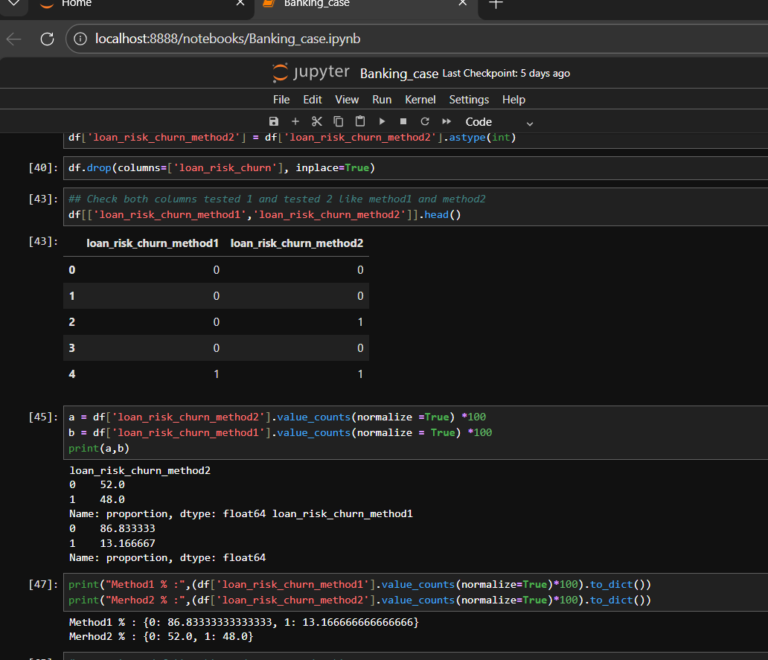

4.3 Risk Model Score Creation
A custom weighted risk score (0–100) was developed using:
- Debt-to-income ratio
- Risk score
- Bank deposits (inverse effect)
- Total debt
This score provides a continuous measure of customer risk, rather than a simple yes/no label.

4.4 Risk Segmentation
Customers were classified into:
- Low Risk (Score < 40)
- Medium Risk (40–70)
- High Risk (>70)
This segmentation enables targeted business actions.
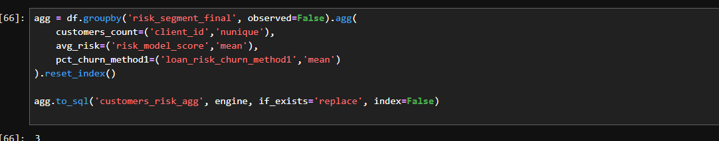

5. Data Storage (MySQL)
Two tables were created:
- First Table :- customers_cleaned
- Customer-level detailed data
- Used for deep analysis and Power BI visuals
b) Seccond Table :- customers_risk_agg
- Aggregated KPIs by risk segment
- Optimized for dashboard performance
Using MySQL reflects enterprise-level data pipelines, where Power BI connects to structured databases.
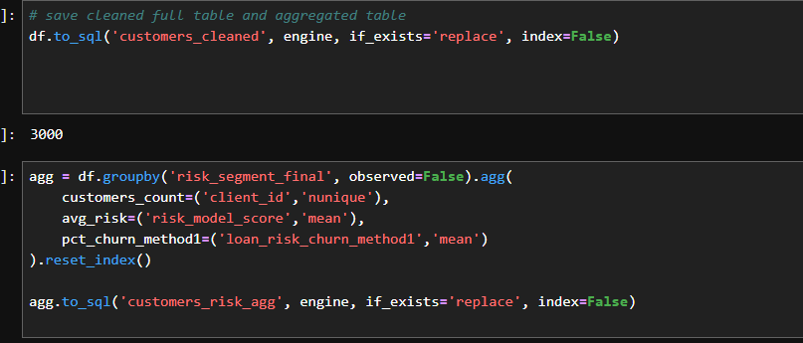

Safe way to create a pipeline
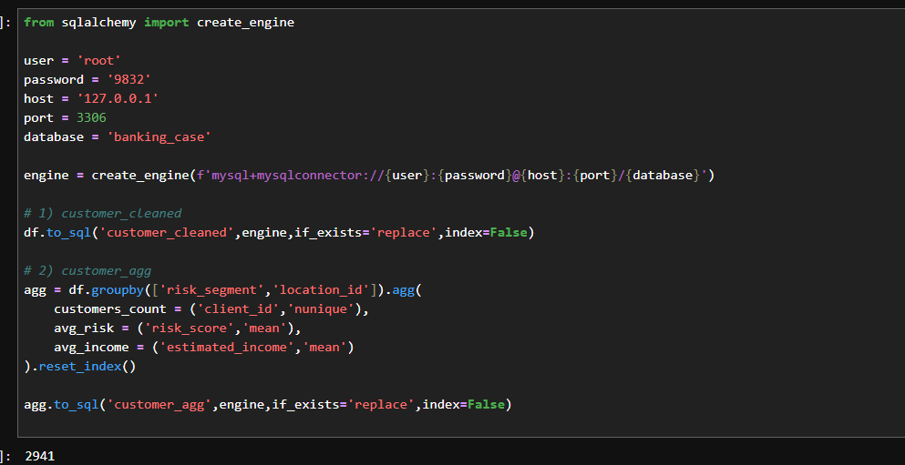

6. Power BI Dashboard Overview (6 Pages)
The dashboard is designed for both executives and analysts.
Page 1: Executive Overview
Purpose:
Provide a high-level snapshot of Customer loan risk.
Key Metrics:
- Total customers
- Loan risk churn %
- Average risk score
Visuals:
- Donut chart: Customer distribution by risk segment
- Bar chart: Customer count by risk segment
Business Insight:
Most customers are low to medium risk, but a small high-risk segment requires attention.
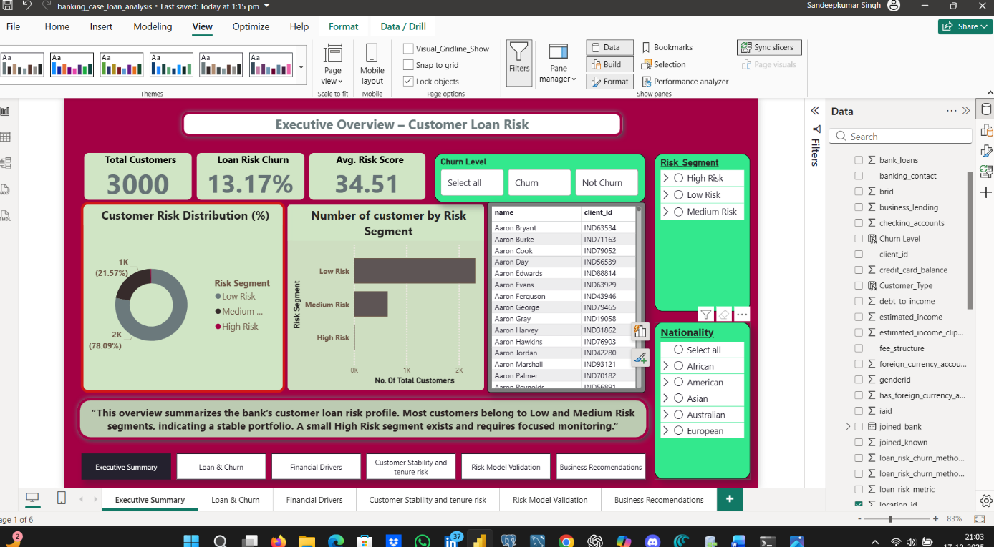
Page 2: Loan Risk & Churn Analysis
Purpose:
Understand how churn is distributed across risk segments.
Visuals:
- Stacked column chart:
Risk segment vs churned / non-churned customers
Insight:
Medium-risk customers show higher churn volume due to larger population size, while high-risk customers show higher churn intensity.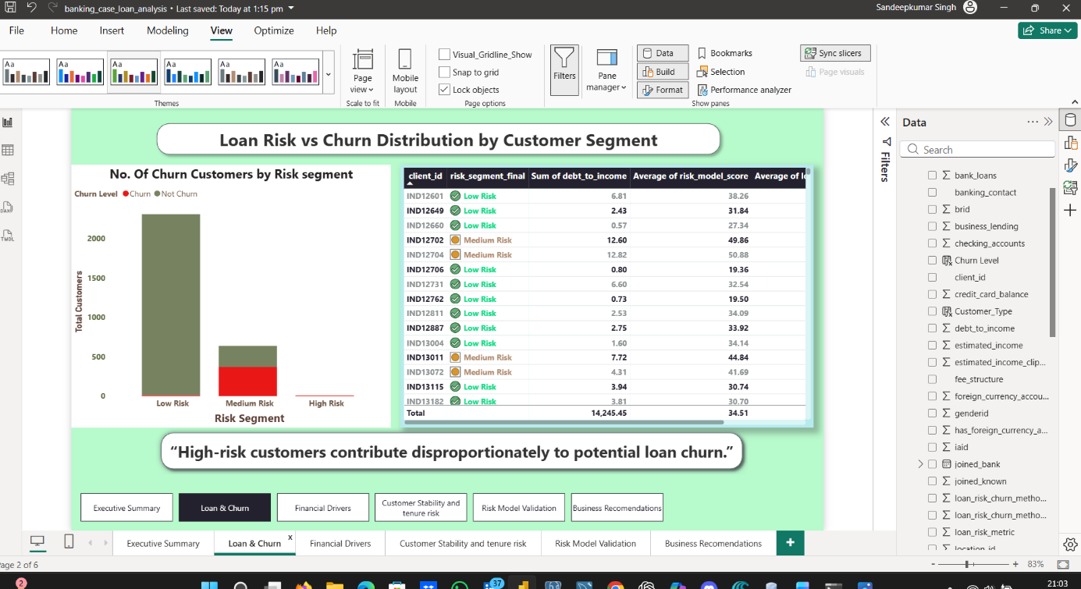

Page 3: Financial Drivers
Purpose:
Identify financial variables driving risk.
Visuals:
- Scatter plot
  - X: Debt-to-income
  - Y: Risk model score
  - Size: Total debt
  - Color: Risk segment
- Bar chart
  - Average bank deposits by risk segment
Insight:
Customers with high debt burden and low savings consistently appear in higher risk segments.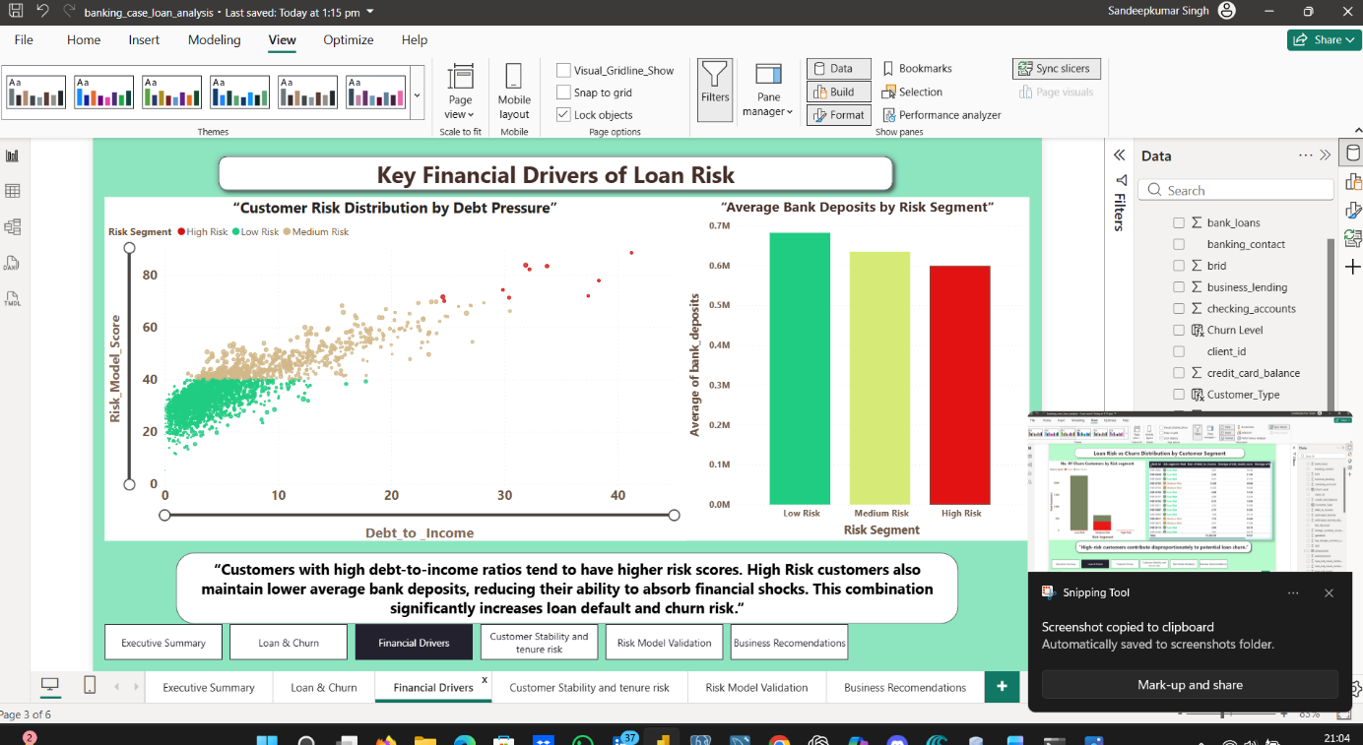

Page 4: Customer Stability
Purpose:
Analyze risk behavior over customer tenure.
Visuals:
- Line chart
  - Years with bank vs average risk score
- Bar chart
  - Churn %: New vs long-term customers
Insight:
New customers tend to have higher risk and churn, indicating the need for stronger early engagement.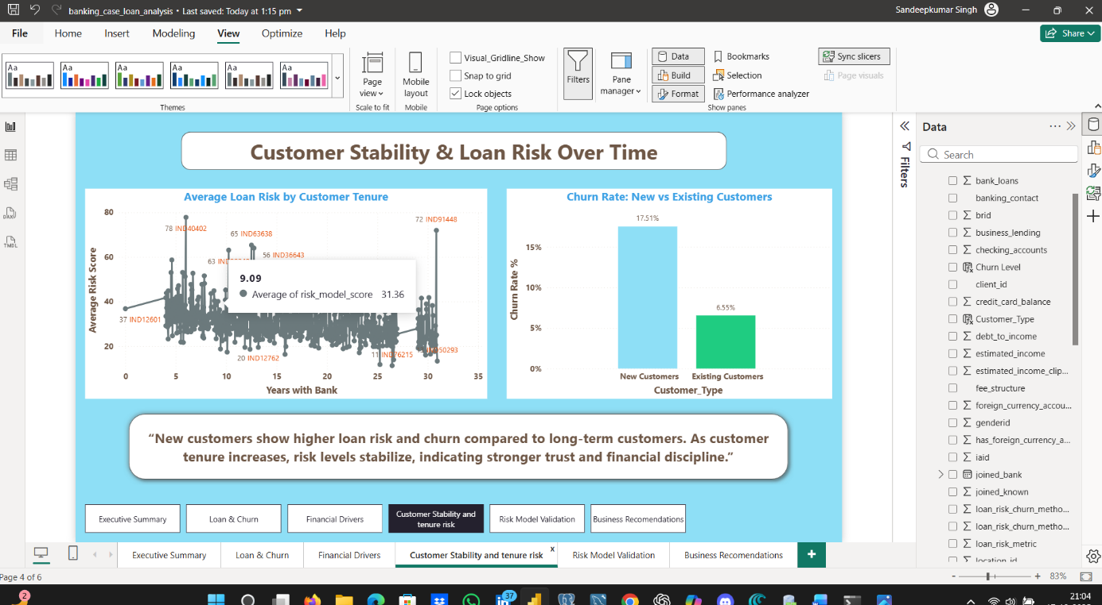

Page 5: Risk Model Validation
Purpose:
Validate whether the model segments customers meaningfully.
Visuals:
- Risk score distribution by segment
- Churn rate by risk segment
- Key Influencers visual (loan risk churn)
Insight:
Risk increases progressively from Low → Medium → High, confirming the model behaves logically.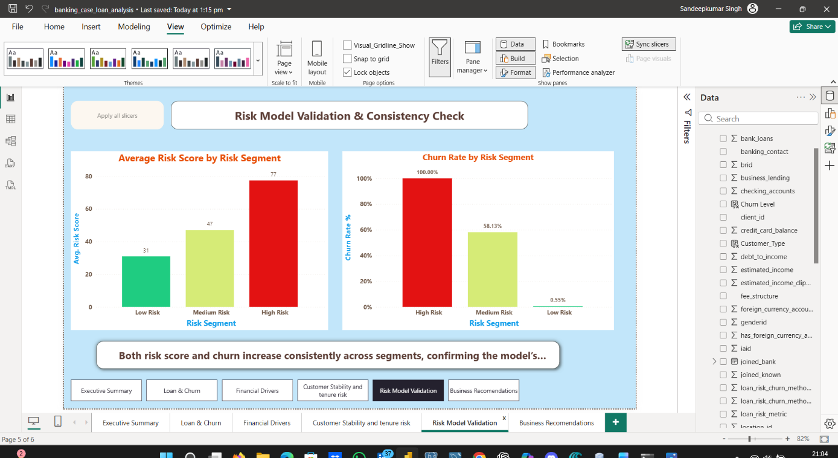

Page 6: Business Recommendations
Purpose:
Convert insights into actionable strategies.
Example Actions:
- High Risk: Reduce credit exposure, proactive monitoring
- Medium Risk: Retention offers, financial guidance
- Low Risk: Upsell opportunities
Visuals:
- Risk segment vs recommended action
- KPI summary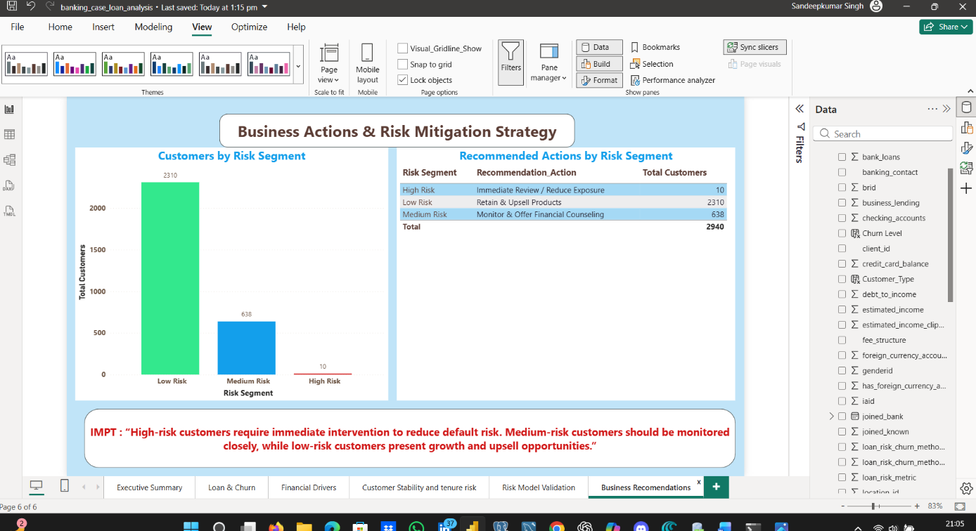

Screenshots of some Calculate Columns and Measures are created on this project using DAX functions
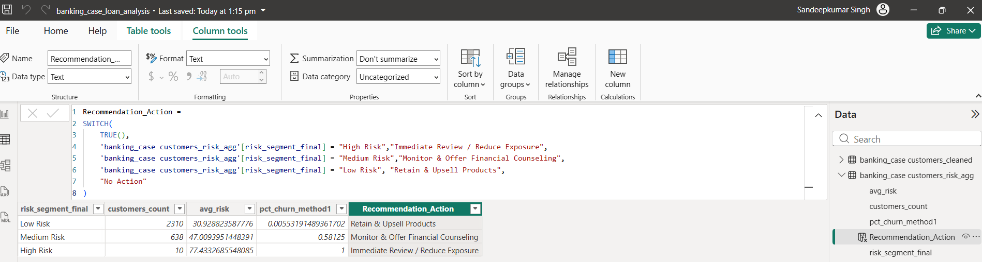
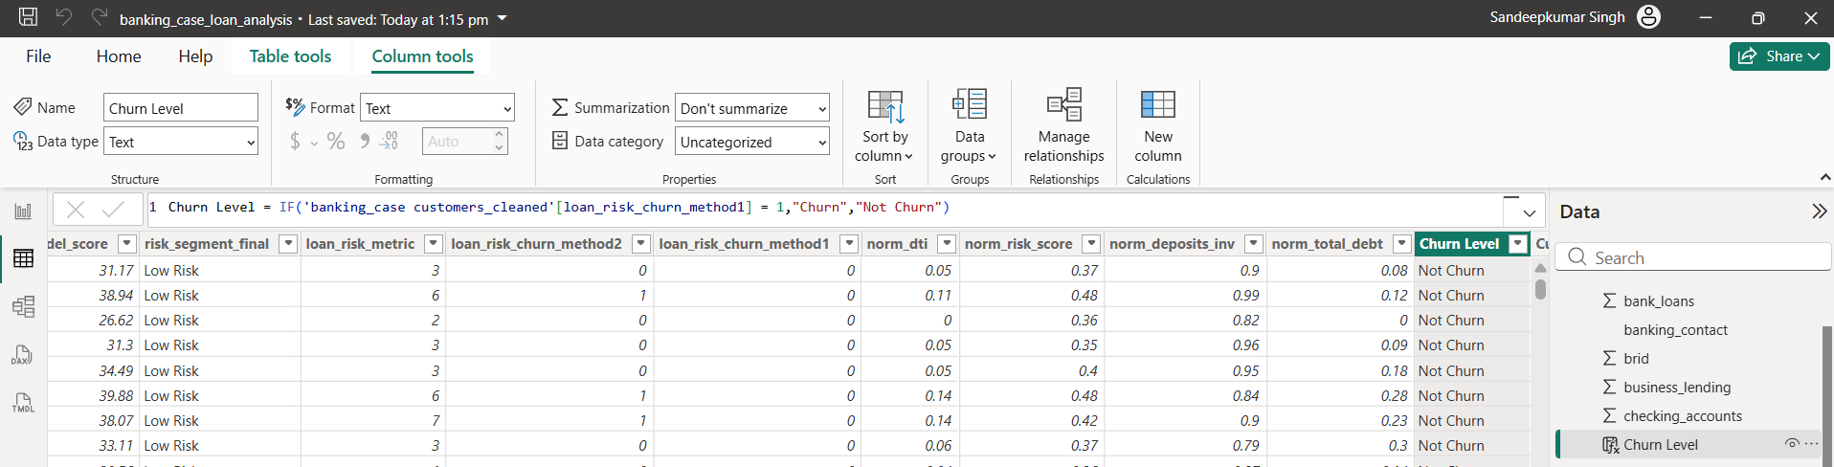
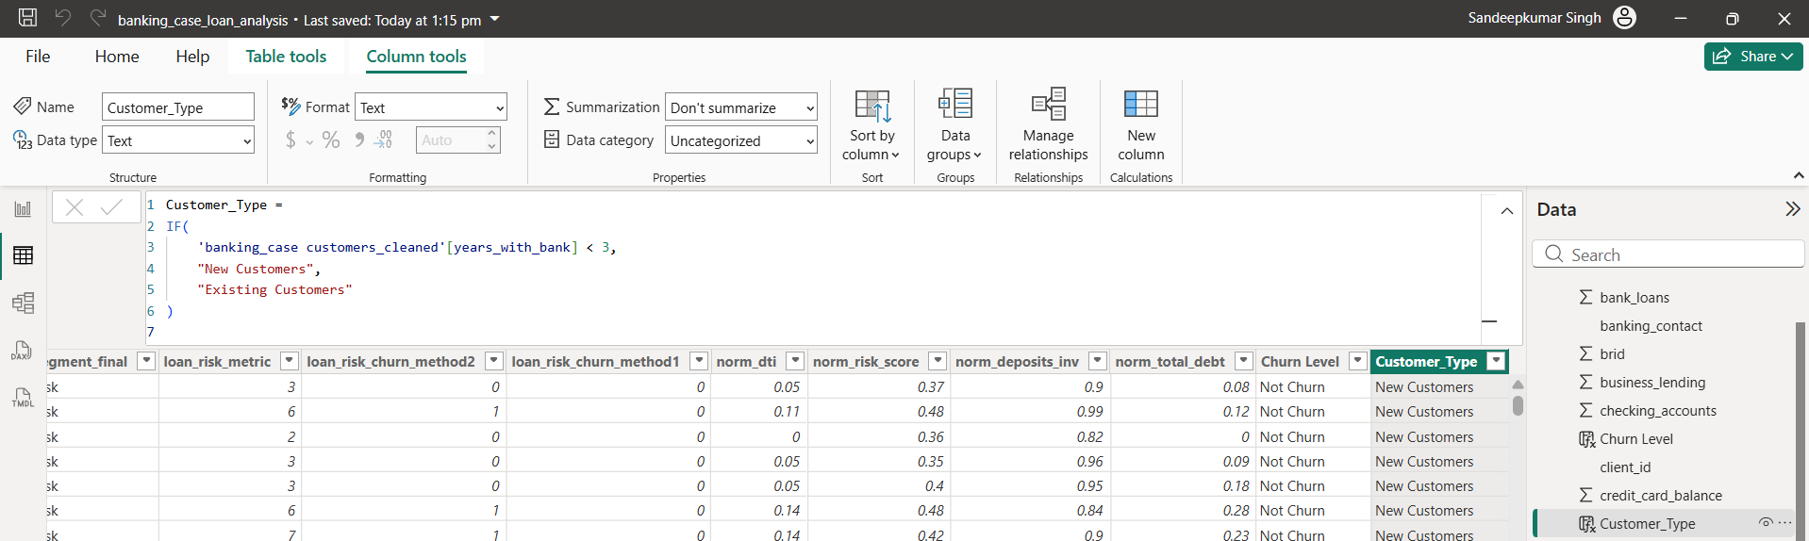
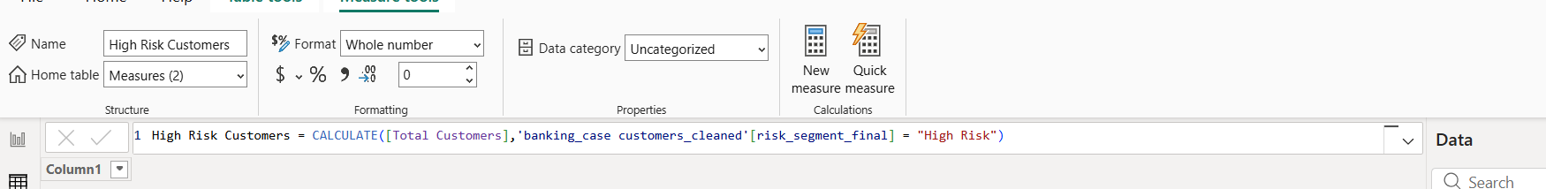
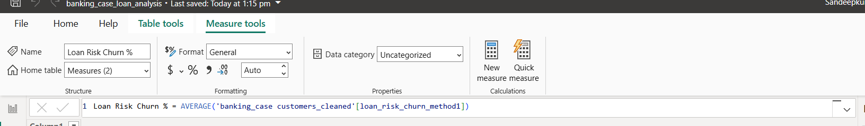
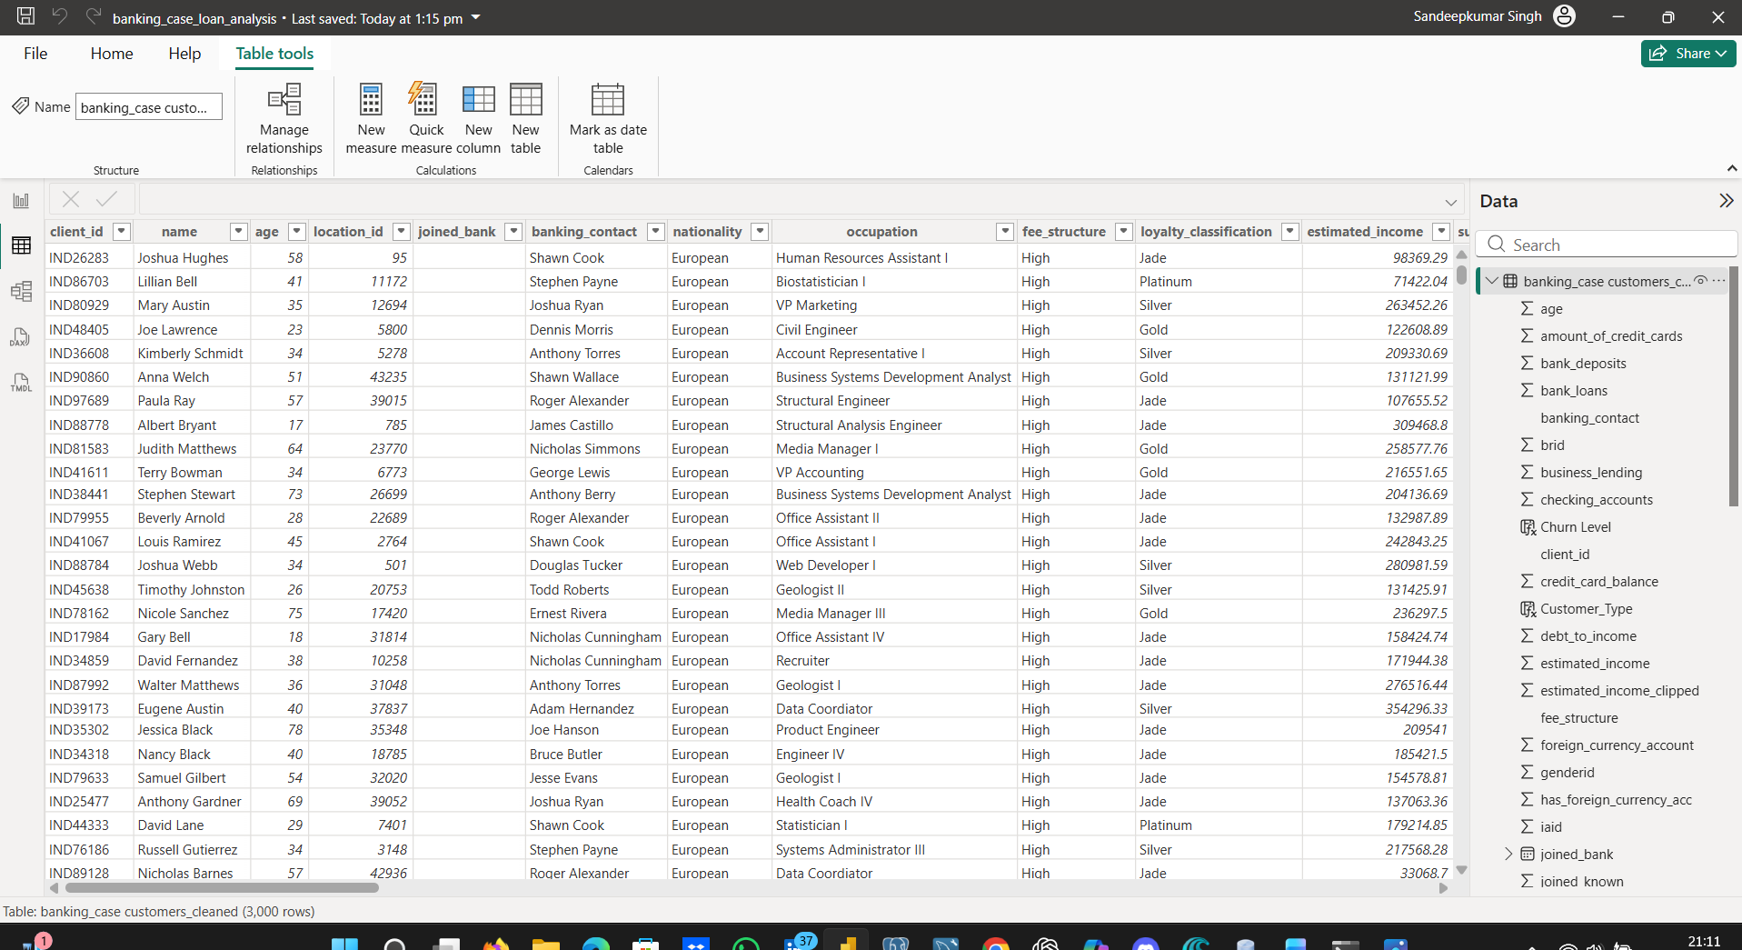

7. Business Impact
This solution enables the bank to:
- Proactively identify risky customers
- Reduce loan default losses
- Improve customer retention
- Allocate resources efficiently
- Support data-driven executive decisions

8. Tools Used
- Python (Pandas, NumPy,Scikit-learn)
- Jupyter Notebook
- MySQL
- Power BI
- SQLAlchemy
9. Conclusion
This project demonstrates strong skills in:
- Data cleaning and feature engineering
- Risk modeling and segmentation
- SQL-based data pipelines
- Executive-level dashboard design
- Business storytelling with data

